**Ques1: HTML code that illustrates an ordered list, an unordered list, and a description list:**

<!DOCTYPE html>

<html lang="en">

<head>

<meta charset="UTF-8">

<meta name="viewport" content="width=device-width, initial-scale=1.0">

<title>List Examples</title>

</head>

<body>

<h2>1. Ordered List:</h2>

<ol>

<li>Item 1</li>

<li>Item 2</li>

<li>Item 3</li>

</ol>

<h2>2. Unordered List:</h2>

<ul>

<li>Apple</li>

<li>Orange</li>

<li>Banana</li>

</ul>

<h2>3. Description List:</h2>

<dl>

<dt>HTML</dt>

<dd>HyperText Markup Language</dd>

<dt>CSS</dt>

<dd>Cascading Style Sheets</dd>

<dt>JavaScript</dt>

<dd>A programming language that enables interactive web pages</dd>

</dl>

</body>

</html>

<---Output--->

**1. Ordered List:**

1. Item 1
2. Item 2
3. Item 3

**2. Unordered List:**

* Apple
* Orange
* Banana

**3. Description List:**

HTML

HyperText Markup Language

CSS

Cascading Style Sheets

JavaScript

A programming language that enables interactive web pages

**Ques2: HTML code that demonstrates the use of inline CSS, external CSS, and internal (embedded) CSS.**

<!DOCTYPE html>

<html lang="en">

<head>

<meta charset="UTF-8">

<meta name="viewport" content="width=device-width, initial-scale=1.0">

<title>CSS Examples</title>

<!-- External CSS -->

<link rel="stylesheet" href="styles.css">

<style>

/* Internal (Embedded) CSS */

body {

font-family: Arial, sans-serif;

background-color: #f0f0f0;

color: #333;

}

/* Inline CSS (applied to this paragraph only) */

p {

font-size: 18px;

color: blue;

font-weight: bold;

}

</style>

</head>

<body>

<h2>1. External CSS:</h2>

<p class="external-style">This paragraph has external CSS styling.</p>

<h2>2. Internal (Embedded) CSS:</h2>

<p>This paragraph has internal CSS styling.</p>

<h2>3. Inline CSS:</h2>

<p style="color: green; font-style: italic;">This paragraph has inline CSS styling.</p>

</body>

</html>

**Output-:**

## 1. External CSS:

**This paragraph has external CSS styling.**

## 2. Internal (Embedded) CSS:

**This paragraph has internal CSS styling.**

## 3. Inline CSS:

***This paragraph has inline CSS styling.***

**Ques3: Create html document form using table tag contain all details.**

<!DOCTYPE html>

<html lang="en">

<head>

<meta charset="UTF-8">

<meta name="viewport" content="width=device-width, initial-scale=1.0">

<link href="https://cdn.jsdelivr.net/npm/tailwindcss@2.2.19/dist/tailwind.min.css" rel="stylesheet">

<title>Student Registration Form</title>

<style>

/* Add any custom styles here */

.cpy {

text-shadow: 1px 1px;

}

</style>

</head>

<body class="bg-green-200 min-h-screen flex items-center justify-center">

<div class="bg-green-100 p-8 rounded shadow-md md:w-96 w-full">

<h2 class="text-2xl font-semibold mb-4">Student Registration</h2>

<form id="registrationForm" class="w-full">

<table class="w-full">

<tr>

<td class="mb-4">

<label for="name" class="block text-gray-700 text-sm font-bold mb-2">Name:</label>

</td>

<td class="mb-4">

<input type="text" id="name" name="name" class="w-full p-2 border rounded">

</td>

</tr>

<tr>

<td class="mb-4">

<label for="email" class="block text-gray-700 text-sm font-bold mb-2">Email:</label>

</td>

<td class="mb-4">

<input type="email" id="email" name="email" class="w-full p-2 border rounded">

</td>

</tr>

<tr>

<td class="mb-4">

<label for="password" class="block text-gray-700 text-sm font-bold mb-2">Password:</label>

</td>

<td class="mb-4">

<input type="password" id="password" name="password" class="w-full p-2 border rounded">

</td>

</tr>

<tr>

<td class="mb-4">

<label for="gender" class="block text-gray-700 text-sm font-bold mb-2">Gender:</label>

</td>

<td class="mb-4">

<select id="gender" name="gender" class="w-full p-2 border rounded">

<option value="" disabled selected>Select gender</option>

<option value="male">Male</option>

<option value="female">Female</option>

<option value="other">Other</option>

</select>

</td>

</tr>

<tr>

<td class="mb-4">

<label for="mobile" class="block text-gray-700 text-sm font-bold mb-2">Mobile Number:</label>

</td>

<td class="mb-4">

<input type="tel" id="mobile" name="mobile" class="w-full p-2 border rounded">

</td>

</tr>

<tr>

<td colspan="2">

<button type="submit" class="w-full bg-blue-500 text-white p-2 rounded hover:bg-blue-600">Register</button>

</td>

</tr>

</table>

</form>

<br>

<footer>

</footer>

<p class="cpy">&copy; 2023 [Saurabh Tiwari]. All rights reserved.</p>

</div>

<script>

document.getElementById("registrationForm").addEventListener("submit", function (event) {

event.preventDefault();

// You can add your JavaScript validation or form submission logic here

});

</script>

</body>

</html>

**Ques4: Create a html document using (Form tag).**

<!DOCTYPE html>

<html lang="en">

<head>

<meta charset="UTF-8">

<meta name="viewport" content="width=device-width, initial-scale=1.0">

<title>Complete Form Example</title>

<style>

body {

font-family: Arial, sans-serif;

background-color: #3f5a7d; /* Updated background color */

color: #000000;

margin: 20px;

}

form {

max-width: 80%; /* Adjusted max-width for responsiveness */

margin: 0 auto;

background-color: rgba(255, 176, 176, 0.8); /* Adjusted background color with opacity */

padding: 20px;

border-radius: 8px;

box-shadow: 0 0 10px rgba(0, 0, 0, 0.1);

}

label {

display: block;

margin-bottom: 8px;

}

input,

select,

textarea {

width: 100%;

padding: 8px;

margin-bottom: 12px;

border: 1px solid #ccc;

border-radius: 4px;

box-sizing: border-box;

}

.cpy{

text-align: center;

text-shadow: 1px 1px 1px rgb(23, 81, 255);

}

button {

background-color: #4caf50;

color: #dfcbcb;

padding: 10px 15px;

border: none;

border-radius: 4px;

cursor: pointer;

}

button:hover {

background-color: #3000e0;

}

/* Responsive styles */

@media only screen and (max-width: 768px) {

form {

max-width: 100%; /* Adjusted max-width for small screens */

}

}

</style>

</head>

<body>

<form>

<h2>Contact Form</h2>

<label for="name">Name:</label>

<input type="text" id="name" name="name" required>

<label for="email">Email:</label>

<input type="email" id="email" name="email" required>

<label>Gender:</label>

<label><input type="radio" name="gender" value="male"> Male</label>

<label><input type="radio" name="gender" value="female"> Female</label>

<label for="age">Age:</label>

<input type="number" id="age" name="age">

<label>Interests:</label>

<label><input type="checkbox" name="interests" value="programming"> Programming</label>

<label><input type="checkbox" name="interests" value="design"> Design</label>

<label><input type="checkbox" name="interests" value="sports"> Sports</label>

<br>

<label for="country">Country:</label>

<select id="country" name="country">

<option value="india">India</option>

<option value="canada">Canada</option>

<option value="uk">United Kingdom</option>

</select>

<label for="message">Message:</label>

<textarea id="message" name="message" rows="4"></textarea>

<button type="submit">Submit</button>

<br>

<p class="cpy">&copy; 2023 [Saurabh Tiwari]. All rights reserved.</p>

</form>

</body>

</html>

**OUTPUT**

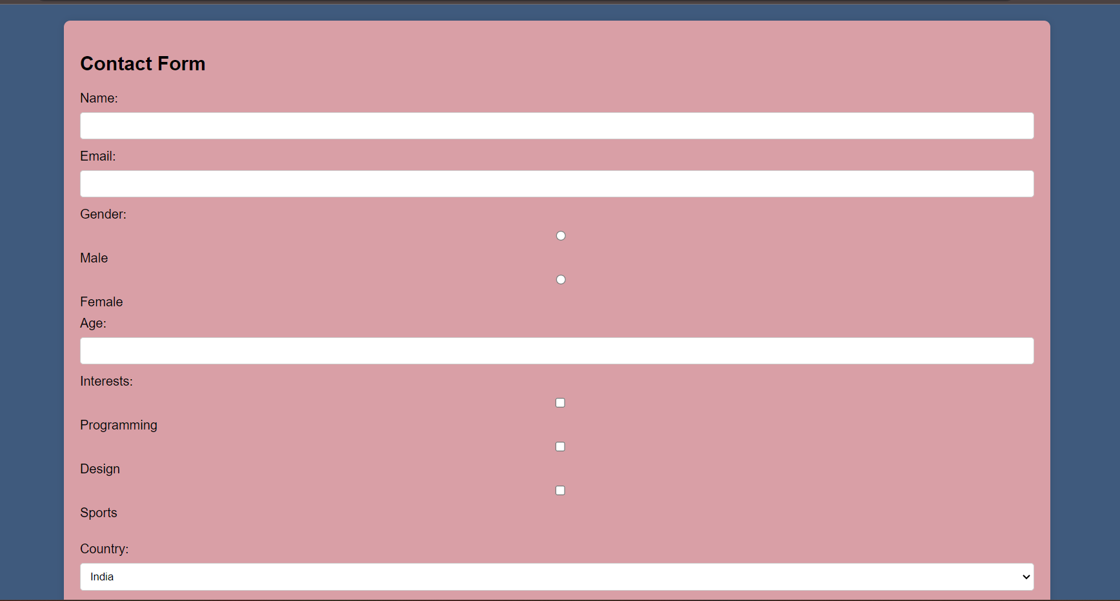

**Ques5: Create html document with four frame that contained basic information about page, links, image and table tag.**

<!DOCTYPE html>

<html lang="en">

<head>

<meta charset="UTF-8">

<meta name="viewport" content="width=device-width, initial-scale=1.0">

<title>Basic Information</title>

</head>

<body>

<h1>Welcome to the Basic Information Frame</h1>

<p><h2>Lorem ipsum dolor sit amet consectetur adipisicing elit. Neque voluptatum accusamus in quod voluptate ea asperiores corporis accusantium vel incidunt, nulla blanditiis possimus optio natus cupiditate sed quos quasi facilis corrupti sequi. Similique, minus? Optio quis illo quasi, labore alias corrupti necessitatibus velit, numquam quas officiis possimus dolorum soluta a explicabo commodi ullam, aut itaque porro assumenda dolorem est ipsum provident repellendus nemo! Minus adipisci omnis, voluptate nostrum maxime sunt quae, iusto nobis aspernatur veritatis accusantium quasi aliquam sequi distinctio? Accusamus dolorum laboriosam, est repudiandae distinctio quibusdam. Nulla voluptatem vero laudantium, maxime deleniti eum laborum assumenda unde dolorum placeat? Eos.</h2></p>

</body>

</html>

**OUTPUT-**

# **Welcome to the Basic Information Frame**

## Lorem ipsum dolor sit amet consectetur adipisicing elit. Neque voluptatum accusamus in quod voluptate ea asperiores corporis accusantium vel incidunt, nulla blanditiis possimus optio natus cupiditate sed quos quasi facilis corrupti sequi. Similique, minus? Optio quis illo quasi, labore alias corrupti necessitatibus velit, numquam quas officiis possimus dolorum soluta a explicabo commodi ullam, aut itaque porro assumenda dolorem est ipsum provident repellendus nemo! Minus adipisci omnis, voluptate nostrum maxime sunt quae, iusto nobis aspernatur veritatis accusantium quasi aliquam sequi distinctio? Accusamus dolorum laboriosam, est repudiandae distinctio quibusdam. Nulla voluptatem vero laudantium, maxime deleniti eum laborum assumenda unde dolorum placeat? Eos.

5.b-:

<!DOCTYPE html>

<html lang="en">

<head>

<meta charset="UTF-8">

<meta name="viewport" content="width=device-width, initial-scale=1.0">

<title>Links</title>

</head>

<body>

<h1>Welcome to the Links Frame</h1>

<ul>

<li><a href="https://example.com" target="content">Visit Example.com</a></li>

<li><a href="https://developer.mozilla.org" target="content">MDN Web Docs</a></li>

</ul>

</body>

</html>

OUTPUT-

Welcome to the Links Frame

[Visit Example.com](https://example.com/)

[MDN Web Docs](https://developer.mozilla.org/)

5.c-:

<!DOCTYPE html>

<html lang="en">

<head>

<meta charset="UTF-8">

<meta name="viewport" content="width=device-width, initial-scale=1.0">

<title>Images</title>

</head>

<body>

<h1>Welcome to the Images Frame</h1>

<img src="saurabh.jpg" alt="Placeholder Image">

</body>

</html>

**OUTPUT-**

# **Welcome to the Images Frame**



5.d-: <!DOCTYPE html>

<html lang="en">

<head>

<meta charset="UTF-8">

<meta name="viewport" content="width=device-width, initial-scale=1.0">

<title>Table</title>

</head>

<body>

<h1>Welcome to the Table Frame</h1>

<table border="1">

<tr>

<th>Header 1</th>

<th>Header 2</th>

</tr>

<tr>

<td>Row 1, Cell 1</td>

<td>Row 1, Cell 2</td>

</tr>

<tr>

<td>Row 2, Cell 1</td>

<td>Row 2, Cell 2</td>

</tr>

</table>

</body>

</html>

OUTPUT-

Welcome to the Table Frame

|  |  |
| --- | --- |
| Header 1 | Header 2 |
| Row 1, Cell 1 | Row 1, Cell 2 |
| Row 2, Cell 1 | Row 2, Cell 2 |

**Ques6: Write a html code to design a entry form of a student details and send it to database server like monodb.**

<!DOCTYPE html>

<html lang="en">

<head>

<meta charset="UTF-8">

<meta name="viewport" content="width=device-width, initial-scale=1.0">

<title>Student Entry Form</title>

<style>

body {

font-family: Arial, sans-serif;

background-color: #f4f4f4;

color: #333;

margin: 20px;

}

form {

max-width: 600px;

margin: 0 auto;

background-color: #fff;

padding: 20px;

border-radius: 8px;

box-shadow: 0 0 10px rgba(0, 0, 0, 0.1);

}

label {

display: block;

margin-bottom: 8px;

}

input,

select {

width: 100%;

padding: 8px;

margin-bottom: 12px;

border: 1px solid #ccc;

border-radius: 4px;

box-sizing: border-box;

}

button {

background-color: #4caf50;

color: #fff;

padding: 10px 15px;

border: none;

border-radius: 4px;

cursor: pointer;

}

button:hover {

background-color: #45a049;

}

/* Responsive styles */

@media only screen and (max-width: 768px) {

form {

max-width: 100%;

}

}

/* Copyright styles */

.copyright {

text-align: center;

margin-top: 20px;

color: #f40000;

}

</style>

</head>

<body>

<form id="studentForm">

<h2>Student Entry Form</h2>

<label for="name">Name:</label>

<input type="text" id="name" name="name" required>

<label for="email">Email:</label>

<input type="email" id="email" name="email" required>

<label for="course">Course:</label>

<input type="text" id="course" name="course" required>

<label for="gender">Gender:</label>

<select id="gender" name="gender">

<option value="male">Male</option>

<option value="female">Female</option>

<option value="other">Other</option>

</select>

<label for="age">Age:</label>

<input type="number" id="age" name="age">

<button type="submit">Submit</button>

</form>

<p class="copyright">&copy; 2023 [Saurabh Tiwari]. All rights reserved.</p>

<script>

document.getElementById("studentForm").addEventListener("submit", function (event) {

event.preventDefault();

// Get form data

const name = document.getElementById("name").value;

const email = document.getElementById("email").value;

const course = document.getElementById("course").value;

const gender = document.getElementById("gender").value;

const age = document.getElementById("age").value;

// Process the form data (you can send it to a server, etc.)

console.log("Form data:", { name, email, course, gender, age });

});

</script>

</body>

</html>

**Output**

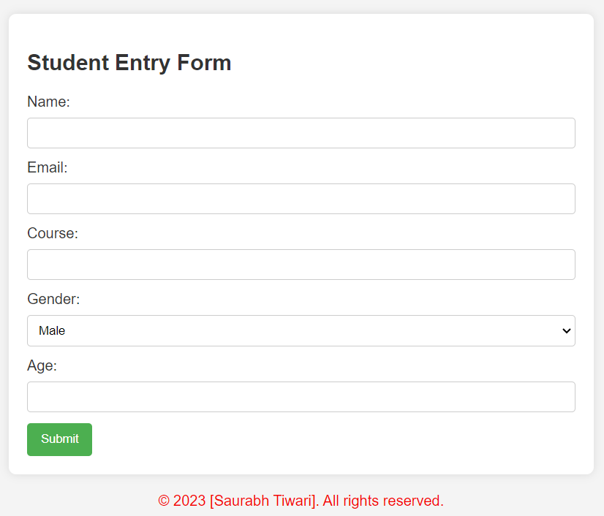

**Ques7: Create an applit which will have a line ,square, oval and rectangle.**

<!DOCTYPE html>

<html lang="en">

<head>

<meta charset="UTF-8">

<meta name="viewport" content="width=device-width, initial-scale=1.0">

<title>Shapes Drawing App</title>

<style>

canvas {

border: 1px solid #000;

background-color: aqua;

}

</style>

</head>

<body>

<h1>Shapes Drawing App</h1>

<canvas id="shapesCanvas" width="500" height="500"></canvas>

<script>

document.addEventListener("DOMContentLoaded", function () {

const canvas = document.getElementById("shapesCanvas");

const context = canvas.getContext("2d");

// Draw a line

context.beginPath();

context.moveTo(50, 50);

context.lineTo(150, 50);

context.stroke();

// Draw a square

context.beginPath();

context.rect(50, 100, 100, 100);

context.stroke();

// Draw an oval

context.beginPath();

context.ellipse(300, 150, 50, 80, 0, 0, 2 * Math.PI);

context.stroke();

// Draw a rectangle

context.beginPath();

context.rect(200, 250, 150, 80);

context.stroke();

});

</script>

</body>

</html>

**OUTPUT-**

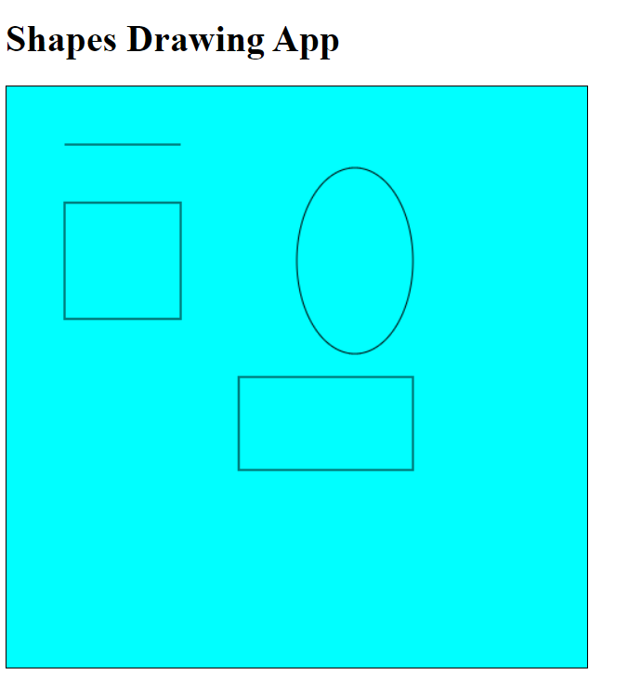

**Ques8:Write a program in XML for creation of (DTD) which specify a set of rule.**

<!-- AddressBook.dtd -->

<!ELEMENT AddressBook (Contact+)>

<!ELEMENT Contact (FirstName, LastName, Email, PhoneNumber?)>

<!ELEMENT FirstName (#PCDATA)>

<!ELEMENT LastName (#PCDATA)>

<!ELEMENT Email (#PCDATA)>

<!ELEMENT PhoneNumber (#PCDATA)>

<!-- Example XML document using the DTD -->

<!-- AddressBook.xml -->

<!DOCTYPE AddressBook SYSTEM "AddressBook.dtd">

<AddressBook>

<Contact>

<FirstName>John</FirstName>

<LastName>Doe</LastName>

<Email>john.doe@example.com</Email>

<PhoneNumber>8948905711</PhoneNumber>

</Contact>

<Contact>

<FirstName>Saurabh</FirstName>

<LastName>Tiwari</LastName>

<Email>stw284701@gmail.com</Email>

</Contact>

</AddressBook>

**OUTPUT-:**

**John Doe john.doe@example.com 8948905711**

**Saurabh Tiwari**[**stw284701@gmail.com**](mailto:stw284701@gmail.com)

**Ques9:Write a javascript program to design a Calculator.**

<!DOCTYPE html>

<html lang="en">

<head>

<meta charset="UTF-8">

<meta name="viewport" content="width=device-width, initial-scale=1.0">

<title>Calculator</title>

<style>

body {

font-family: 'Arial', sans-serif;

display: flex;

justify-content: center;

align-items: center;

height: 100vh;

margin: 0;

background-color: #befff4; /* Set your desired background color */

}

#calculator {

display: grid;

grid-template-columns: repeat(4, 1fr);

gap: 8px;

max-width: 300px;

margin: auto;

background-color: #ffb8b8; /* Set your desired background color */

border-radius: 8px;

box-shadow: 0 4px 8px rgba(0, 0, 0, 0.1);

padding: 16px;

}

input {

grid-column: span 4;

padding: 10px;

font-size: 18px;

text-align: right;

}

button {

padding: 10px;

font-size: 18px;

cursor: pointer;

}

#title {

text-align: center;

font-size: 24px;

margin-bottom: 16px;

}

#footer {

text-align: center;

margin-top: 16px;

font-size: 14px;

color: #ff0000;

}

</style>

</head>

<body>

<div id="calculator">

<div id="title"> Calculator</div>

<input type="text" id="display" disabled>

<button onclick="clearDisplay()">C</button>

<button onclick="appendToDisplay('/')">/</button>

<button onclick="appendToDisplay('*')">*</button>

<button onclick="appendToDisplay('7')">7</button>

<button onclick="appendToDisplay('8')">8</button>

<button onclick="appendToDisplay('9')">9</button>

<button onclick="appendToDisplay('-')">-</button>

<button onclick="appendToDisplay('4')">4</button>

<button onclick="appendToDisplay('5')">5</button>

<button onclick="appendToDisplay('6')">6</button>

<button onclick="appendToDisplay('+')">+</button>

<button onclick="appendToDisplay('1')">1</button>

<button onclick="appendToDisplay('2')">2</button>

<button onclick="appendToDisplay('3')">3</button>

<button onclick="calculateResult()">=</button>

<button onclick="appendToDisplay('0')">0</button>

<button onclick="appendToDisplay('.')">.</button>

<br>

<footer>

<p class="cpy">&copy; 2023 [Saurabh Tiwari]. All rights reserved.</p>

</footer>

</div>

<script>

function appendToDisplay(value) {

document.getElementById('display').value += value;

}

function clearDisplay() {

document.getElementById('display').value = '';

}

function calculateResult() {

const displayValue = document.getElementById('display').value;

try {

const result = eval(displayValue); // Warning: Using eval is not recommended in a production environment.

document.getElementById('display').value = result;

} catch (error) {

document.getElementById('display').value = 'Error';

}

}

</script>

</body>

</html>

**OUTPUT**

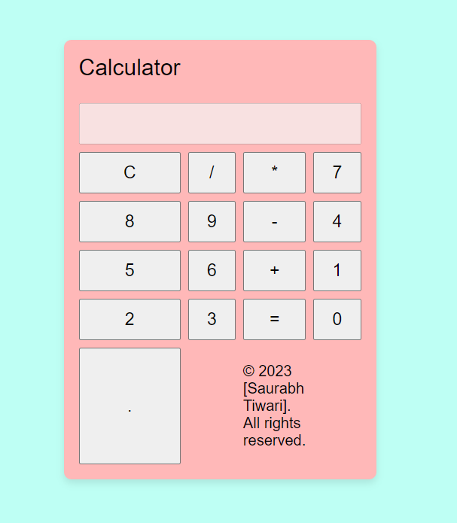

**Ques10:Write a javascript program to calculating the square and qubes of number.**

<!DOCTYPE html>

<html lang="en">

<head>

<meta charset="UTF-8">

<meta name="viewport" content="width=device-width, initial-scale=1.0">

<title>Number Calculator</title>

<style>

body {

font-family: Arial, sans-serif;

background-color: #dbffbe;

margin: 0;

padding: 0;

display: flex;

flex-direction: column;

align-items: center;

justify-content: center;

height: 100vh;

}

form {

background-color: #fff;

padding: 20px;

border-radius: 8px;

box-shadow: 0 4px 8px rgba(0, 0, 0, 0.1);

text-align: center;

}

input {

width: 100%;

padding: 10px;

margin-bottom: 10px;

box-sizing: border-box;

}

button {

background-color: #4caf50;

color: #000000;

padding: 10px 20px;

border: none;

border-radius: 4px;

cursor: pointer;

font-size: 16px;

}

button:hover {

background-color: rgb(43, 0, 255);

}

#result {

margin-top: 20px;

}

#copyright {

text-overflow: auto;

text-align: center;

text-shadow: 1px 1px;

bottom: 10px;

right: 10px;

font-size: 20px;

}

</style>

</head>

<body>

<header>

<h1>Square & Cube Calculator</h1>

</header>

<form onsubmit="calculate(event)">

<label for="number">Enter a number:</label>

<input type="number" id="number" required>

<button type="submit">Calculate</button>

</form>

<div id="result"></div>

<div id="copyright">

<p class="cpy">&copy; 2023 [Saurabh Tiwari]. All rights reserved.</p>

</div>

<script>

function calculate(event) {

event.preventDefault();

var number = document.getElementById('number').value;

var square = Math.pow(number, 2);

var cube = Math.pow(number, 3);

var resultContainer = document.getElementById('result');

resultContainer.innerHTML = `

<p>Square: ${square}</p>

<p>Cube: ${cube}</p>

`;

}

</script>

</body>

</html>

**OUTPUT-**

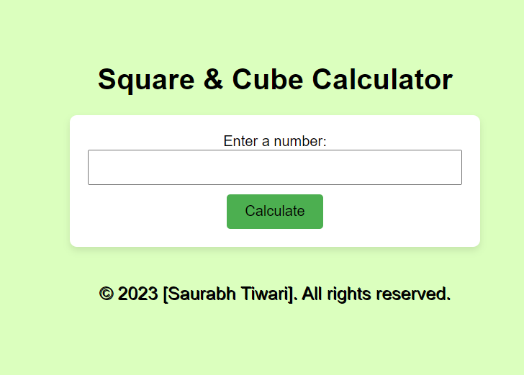

**Ques11: Write a programe for Performing Arithmatic operation using java.**

import java.util.Scanner;

public class ArithmeticOperations {

public static void main(String[] args) {

Scanner scanner = new Scanner(System.in);

// Read the two numbers from the user

System.out.println("Enter the first number: ");

int num1 = scanner.nextInt();

System.out.println("Enter the second number: ");

int num2 = scanner.nextInt();

// Perform the arithmetic operations

int sum = num1 + num2;

int difference = num1 - num2;

int product = num1 * num2;

int quotient = num1 / num2;

int remainder = num1 % num2;

// Print the results

System.out.println("The sum is: " + sum);

System.out.println("The difference is: " + difference);

System.out.println("The product is: " + product);

System.out.println("The quotient is: " + quotient);

System.out.println("The remainder is: " + remainder);

}

}

**OUTPUT-:**

**Enter the first number:**

**10**

**Enter the second number:**

**5**

**The sum is: 15**

**The difference is: 5**

**The product is: 50**

**The quotient is: 2**

**The remainder is: 0**

**Ques12: Write a program to implement object oriented program in java.**

public class MyClass {

private int x;

private int y;

public MyClass(int x, int y) {

this.x = x;

this.y = y;

}

public int getX() {

return x;

}

public void setX(int x) {

this.x = x;

}

public int getY() {

return y;

}

public void setY(int y) {

this.y = y;

}

public static void main(String[] args) {

MyClass myClass = new MyClass(10, 20);

System.out.println(myClass.getX()); // prints 10

System.out.println(myClass.getY()); // prints 20

}

}

**OUTPUT-:**

**10**

**20**

**Ques13:Write a programe to create a window with the help of A.W.T**

import java.awt.*;

public class WindowExample {

public static void main(String[] args) {

Frame f = new Frame("My Window");

f.setSize(300, 300);

f.setVisible(true);

}

}

OUTPUT-:

My Window